ASSESSMENT 2 AT 1

NAME : AKSHAYA S COURSE CODE: CSA0618
REG NO: 192471061 GUIDED BY: DR SAIRAM

Q1 – Sorting Under Different Data Conditions (6 marks)
1. Prediction before implementation
Input condition | Selection sort | Bubble sort | Insertion sort
Random order | Predictable $O\left(n^{2}\right)$comparisons | $O\left(n^{2}\right)$in the usual case | $O\left(n^{2}\right)$in the usual case
Nearly sorted | Still $O\left(n^{2}\right)$comparisons | Can approach $O\left(n\right)$with early stopping | Can approach $O\left(n\right)$
Already sorted | $O\left(n^{2}\right)$comparisons | $O\left(n\right)$with early stopping | $$O\left(n\right)$$
Reverse sorted | $O\left(n^{2}\right)$comparisons | $$O\left(n^{2}\right)$$ | $$O\left(n^{2}\right)$$
Reasoning:
- Selection sort searches the unsorted section for the smallest item each pass. Its comparison count barely changes with the input arrangement.
- Bubble sort repeatedly exchanges adjacent elements. An early-stop flag lets it finish after one pass if the list is already sorted.
- Insertion sort inserts each new element into the sorted prefix. When the list is nearly sorted, only a few shifts are required.

2. PYTHON IMPLEMENTATION
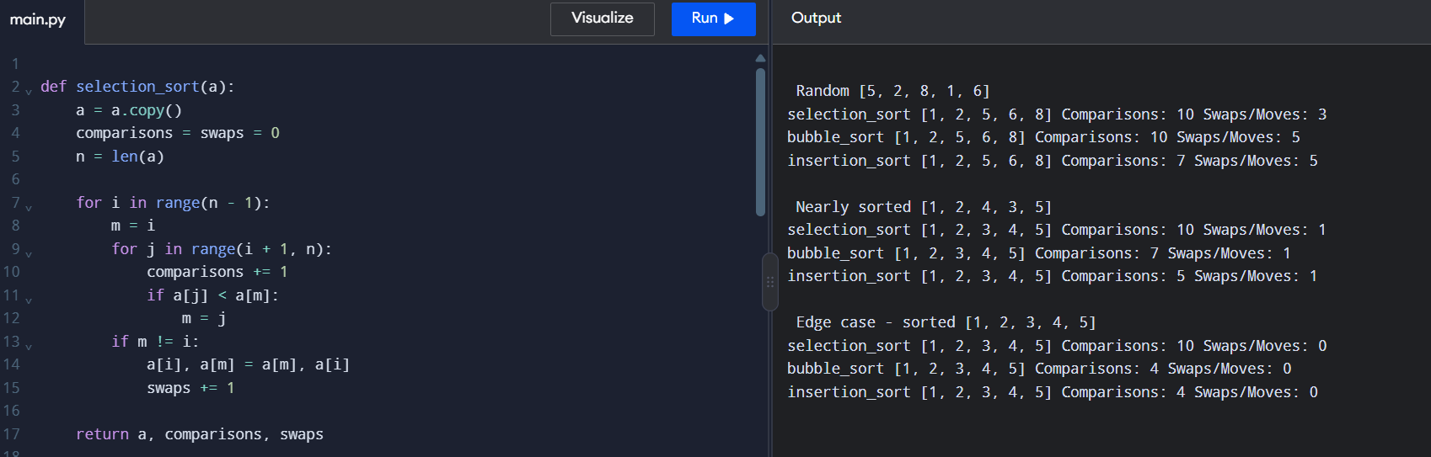
4. Test Datasets
- Dataset 1 – Random: [5, 2, 8, 1, 6]
- Dataset 2 – Nearly sorted: [1, 2, 4, 3, 5]
- Dataset 3 – Already sorted: [1, 2, 3, 4, 5]
5. Result and Design Decision
For five elements, Selection Sort makes 10 comparisons in every test. Optimized Bubble Sort makes 4 comparisons for already sorted data, and Insertion Sort makes 4 comparisons.
Recommendation: Use Insertion Sort because 95% of the orders are already sorted. It handles small batches of new orders efficiently and requires \(O(n)\) time when the data is already sorted.
Q2. When Is Sequential Search Appropriate? (4 Marks)
1. Aim
To analyse Sequential Search using successful and unsuccessful searches for different list sizes.
2. Algorithm
- Start from the first element.
- Compare each element with the target.
- If a match is found, return its position.
- If the list ends, report that the target is not found.

3. python program
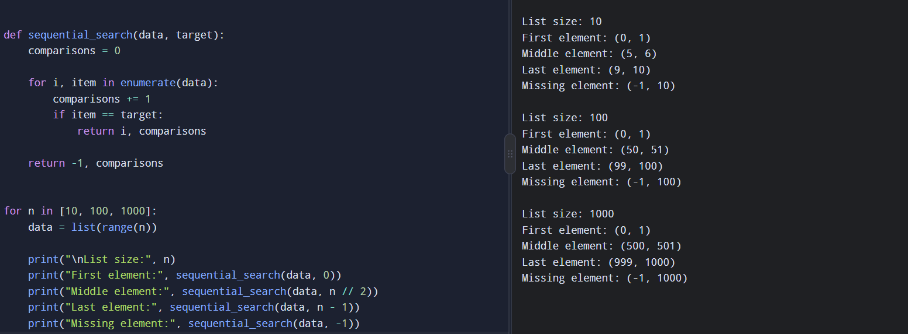
4. Expected Comparison Counts
List size | First element | Middle element | Last element | Unsuccessful
10 | 1 | 6 | 10 | 10
100 | 1 | 51 | 100 | 100
1,000 | 1 | 501 | 1,000 | 1,000
The middle position is rounded down using n // 2, with zero-based indexing.
5. Analysis
- Best case: \(O(1)\)
- Average case: \(O(n)\)
- Worst case: \(O(n)\)
Sequential Search is suitable for small, frequently changing lists and infrequent searches because it needs no sorting or extra index.
For 20 maintenance facilities with many records and frequent searches, a hash table indexed by Tool ID is a better choice. It provides expected \(O(1)\) lookup, although additional memory and index updates are required.
Result: Sequential Search is simple and effective for small lists but becomes inefficient as record counts and lookup frequency increase.
Q3. Brute-Force String Matching (6 Marks)
1. Aim
To investigate how text and pattern structure affects the number of character comparisons in brute-force string matching.
2. Algorithm
- Place the pattern at the beginning of the text.
- Compare pattern characters with text characters.
- If a mismatch occurs, shift the pattern one position.
- Stop when a match is found or all positions are checked.
3. Python Program
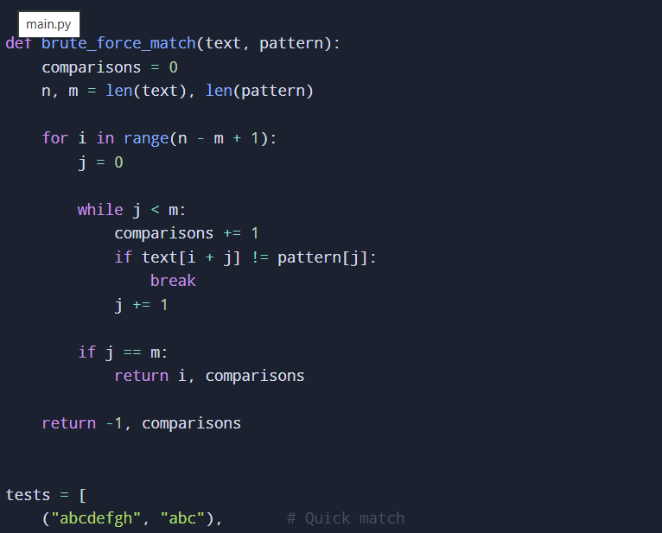

4. Experimental Results
Test condition | Text | Pattern | Comparisons | Prediction
Quick match | abcdefgh | abc | 3 | Low
Repeated comparisons | aaaaaaaaaa | aaaab | 30 | High
No match | abcdefgh | xyz | 6 | Low
5. Analysis
In the second test, four characters match at each of six possible starting positions before the fifth character mismatches. Therefore, the total is \(6 \times 5 = 30\) comparisons.
The algorithm's worst-case time complexity is \(O(nm)\), where \(n\) is the text length and \(m\) is the pattern length.
Result: Repeated matching prefixes increase computational effort. Input length alone cannot predict performance; the character arrangement also matters.
Q4. Brute-Force Closest Pair (6 Marks)
1. Aim
To identify the two closest drones by examining every unique pair and analyse the algorithm's scalability.
2. Mathematical Derivation
For \(n\) drones, each pair contains two different drones. Since pairs such as \((A,B)\) and \((B,A)\) are identical, we examine each pair once.
\[ \text{Number of pairs}=\binom{n}{2} =\frac{n(n-1)}{2} \]
3. Python Program
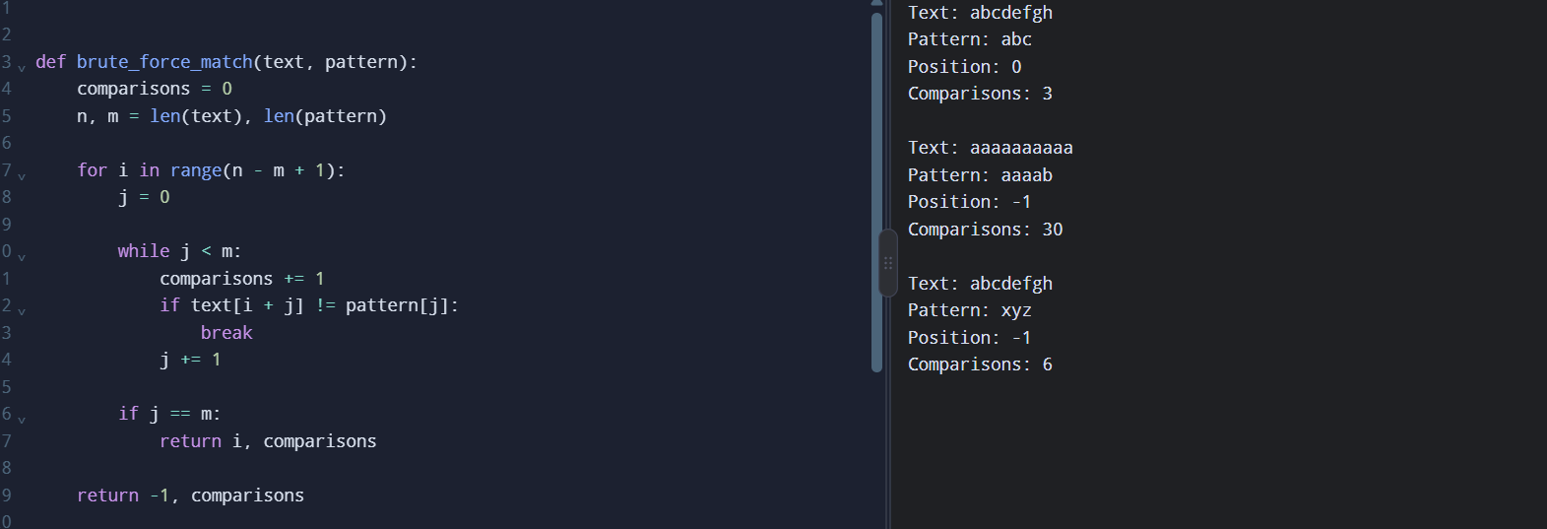
4. Theoretical and Experimental Pair Counts
Drones \(n\) | Unique pairs | Distance calculations
10 | 45 | 45
100 | 4,950 | 4,950
500 | 124,750 | 124,750
5. Analysis
The time complexity is \(O(n^2)\), and the auxiliary space complexity is \(O(1)\), excluding the input and output.
For the experiment, define an acceptable response time as 1 second. Run the program with increasing values of \(n\) and record the first size that exceeds this limit. The exact threshold depends on the computer.
The main inefficiency is examining every possible pair. A redesigned strategy should avoid unnecessary distance calculations, using geometric properties to narrow down candidate pairs.
Result: Brute-force closest-pair search is suitable for small datasets but may become impractical for large drone fleets.

Q5. Brute-Force Convex Hull (7 Marks)
1. Aim
To construct the outer boundary of monitoring stations using a geometric test.
2. Geometric Principle
For three points \(A=(x_1,y_1)\), \(B=(x_2,y_2)\), and \(P=(x_3,y_3)\), calculate the cross product:
\[ C=(x_2-x_1)(y_3-y_1) -(y_2-y_1)(x_3-x_1) \]
- \(C>0\): point \(P\) is on one side of line \(AB\).
- \(C<0\): point \(P\) is on the opposite side.
- \(C=0\): the points are collinear.
If every point lies on the same side of a candidate line, that line may form a convex hull edge.
Important implementation note: The program above identifies candidate supporting segments. To construct a correct polygon for general inputs, collinear points must be handled carefully and the actual extreme endpoints must be selected for each supporting line. The boundary variable above is not a complete hull-ordering implementation.
For the square test, the expected hull vertices are:
(0,0), (4,0), (4,4), (0,4)
The interior points (2,2) and (1,2) should not be hull vertices.
5. Complexity and Correctness
There are \(O(n^2)\) candidate point pairs. Each pair is tested against \(O(n)\) points, giving \(O(n^3)\) time complexity.
The geometric test supports correctness because a supporting line has all points on one side. However, collinear points require special handling to avoid reporting overlapping or non-extreme segments.
Result: The brute-force geometric approach identifies candidate boundary edges, but additional processing is necessary to construct a reliable ordered convex hull.
Q6. Exhaustive Search and Combinatorial Growth (8 Marks)
1. Aim
To select packages that maximise humanitarian value without exceeding the helicopter's payload limit using exhaustive search.
2. Algorithm
- Generate every possible package combination.
- Calculate the total weight and value.
- Reject combinations that exceed the payload limit.
- Retain the feasible combination with the highest value.
- Repeat until all combinations have been checked.
3. python program
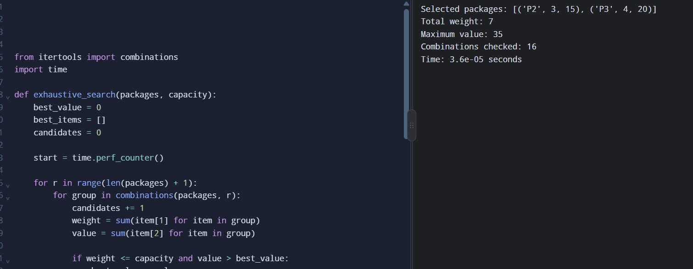
4. Correctness Verification
For the payload limit of 7, the best combination is:
Package | Weight | Value
P1 | 2 | 10
P3 | 4 | 20
Total | 6 | 30
P1 and P3 give a total value of 30 without exceeding the payload limit. Checking all combinations confirms that no feasible combination has a higher value.
5. Growth Investigation
Each package can either be selected or not selected. Therefore, for \(n\) packages:
\[ \text{Number of combinations}=2^n \]
Packages \(n\) | Combinations
5 | 32
10 | 1,024
15 | 32,768
20 | 1,048,576
25 | 33,554,432
The number of combinations doubles whenever one package is added.
6. Deployment Decision
Assume the planner must finish within 1 second. Test increasing package counts and measure actual execution time. For the simple implementation above, the largest deployable size is the largest measured input that consistently finishes within the limit.
The time complexity is \(O(n2^n)\) because the implementation calculates each combination's weight and value by iterating over its selected packages. A redesign could use dynamic programming to reuse results and avoid repeatedly evaluating every combination.
Result: Exhaustive search guarantees the optimal solution for small inputs but becomes impractical as the number of packages increases exponentially.
Q7. Day-4 Design Challenge – Diagnose, Redesign and Validate (13 Marks)
Selected Problem: Exhaustive Search for Package Selection
A. Diagnose the Computational Bottleneck (2 Marks)
The original algorithm examines all \(2^n\) package combinations. For every combination, it recalculates total weight and value.
The main bottlenecks are:
- Exponential growth in the number of combinations.
- Repeated calculation of weight and value.
- Increasing execution time as the number of packages grows.
For example, 10 packages produce 1,024 combinations, while 20 packages produce 1,048,576 combinations.
B. Define the Design Objective (2 Marks)
The objective is to reduce repeated calculations and avoid enumerating every package combination while still finding the maximum possible humanitarian value.
Measurable objective: Obtain the same optimal value as exhaustive search while reducing the number of candidate states evaluated.
C. Design the Revised Computational Strategy (4 Marks)
Use Dynamic Programming (DP). Instead of checking every complete combination, store the best value achievable for each package prefix and each capacity.
Let \(DP[i][w]\) represent the maximum value obtainable using the first \(i\) packages with capacity \(w\).
The recurrence is:
\[ DP[i][w]= \begin{cases} DP[i-1][w], & \text{if } weight_i>w\\ \max(DP[i-1][w],\ value_i+DP[i-1][w-weight_i]), & \text{otherwise} \end{cases} \]

Advantages:
- Reuses previously calculated results.
- Avoids checking every complete combination.
- Guarantees an optimal value for the 0/1 knapsack problem.
Trade-off: It requires \(O(nW)\) time and \(O(nW)\) memory, where \(W\) is the integer capacity. This is pseudo-polynomial, not polynomial in the number of input bits; very large capacities can still be expensive.
D. Predict Before Implementing
Prediction: Dynamic Programming will examine fewer states than exhaustive search for suitable capacities. It should produce the same maximum value while reducing computation for larger package sets with manageable integer capacities.
E. Implement and Validate the Redesign
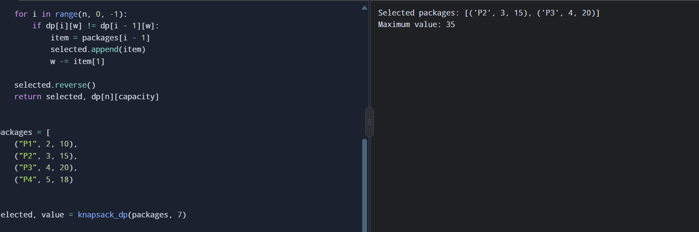
The dynamic programming result should match the exhaustive-search result for the same packages and capacity.
Packages | Exhaustive combinations | DP table states for capacity 7
5 | 32 | 48
10 | 1,024 | 88
15 | 32,768 | 128
20 | 1,048,576 | 168
The DP state count is \((n+1)(W+1)\). These are theoretical counts of table entries, not measured execution times. For a fair comparison, run both programs on the same inputs and record their actual elapsed times.
F. Defend the Final Design
Dynamic Programming is preferable when package weights and capacity are manageable integers because it avoids exhaustive enumeration and retains the optimal solution.
Exhaustive search may still be preferable for very small inputs because it is simpler and needs less additional memory. Dynamic Programming also becomes expensive when the capacity is extremely large.
Final conclusion: The redesign addresses repeated computation by storing and reusing subproblem results. Its effectiveness should be confirmed using identical datasets, comparing the optimal value, operation counts, memory use and execution time.
Overall Conclusion
The experiments demonstrate that an algorithm should be selected based on the characteristics of the input and the required performance.
- Q1: Insertion Sort is suitable for nearly sorted orders.
- Q2: Sequential Search works well for small, frequently changing lists.
- Q3: String structure affects the number of character comparisons.
- Q4: Brute-force closest-pair search requires \(O(n^2)\) time.
- Q5: The geometric test identifies candidate convex hull edges.
- Q6: Exhaustive Search guarantees an optimum but requires exponential time.
- Q7: Dynamic Programming reduces repeated computation for package selection.

THANK YOU

